-------1820 – Immigration changes
1820
-------1834 – Currency Act Led

-------1835 – Federal Debt Retirement

------- 1847 - Mormon pioneers
------- 1850 – Investment Banker
------- 1850 – Power Sources

-------1850 – Management Principles
-------1850 Steel Making
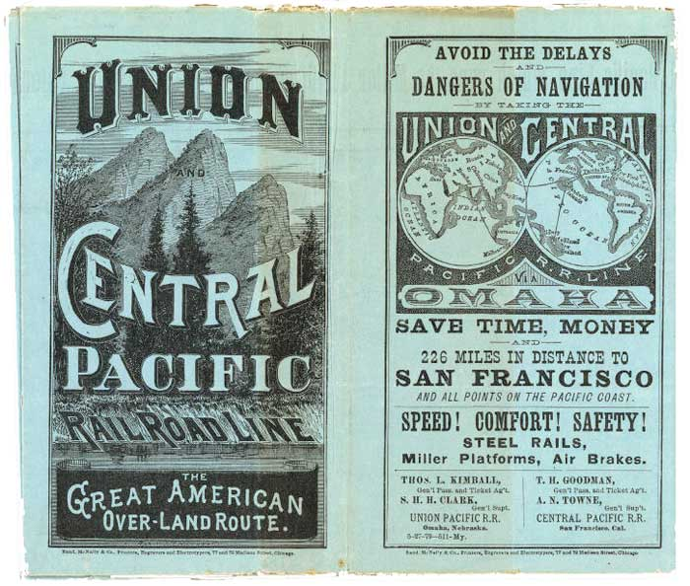
-------

1853- Congress sent government engineers to survey routes.

------- 1857 – American Income

-------1857 – Agriculture

------- 1859 – Income

-------1860 – Railroad Track Progress
-------1860 – Per Capita Deposits & Currency in Circulation

-------1860 - Prices

-------1860 – Manufacturing

------- 1860 – Commercial Bank Stats

-------1860 – Industries
-------1860 – First Corporations
-------1860 – Commodity Output

-------1860 – Agriculture

-------1860 – Forms & Value of U.S Currency

-------1860 – Agriculture

-------1861 – The Central Pacific was given authority to construct

------- 1861 – Financial Panic

-------1861 – Union Forces

-------1861-1862 – English Support
-------1862 – The Northern Platte River route was selected

-------1862 – Railway Act

-------1862 – Government funding for railroad track

-------1862 – Government Funding

------- 1862 – Union Forces

-------1862 – Gold Suspension

------- 1862 – Greenbacks

-------1862 – Pacific Railway Act -

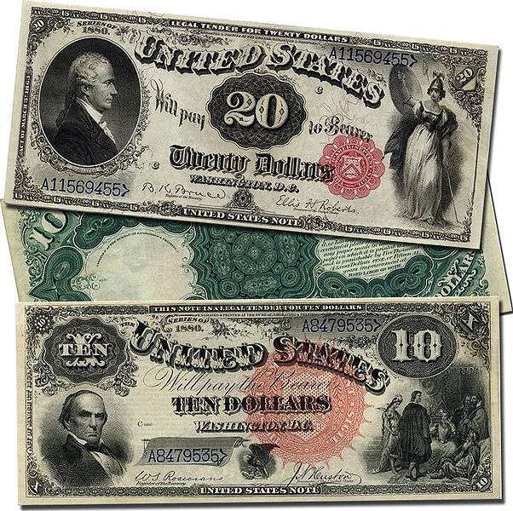
-------1862 – Draft Law
------- 1863 – Union Forces
------- 1863 – Money
------- 1863 – Commercial Bank Stats
------- 1863 – The National Bank Act
-------1863 – Mobs
------- 1863-1864 - Federal Naval Blockade
-------1864 – Contract Labor Law
------- 1864 – Slaves

-------1864 – State Bank Tax
------- 1864 – Gold
------- 1864 – Letter to the Confederate
-------1864 – Land Grants
-------1864 – Reelection
-------1864 – Sherman Marches
------- 1865 – Federal Debt
------- 1865 – Commercial Bank Stats
-------1865 – Contraction Act
-------1865 – Raised State Bank Tax State
------- 1865 – Railroad Track Progress
------- 1866 – Number of State Banks .
-------1866 – Commercial Bank Stats
-------1867 – Commercial Bank Stats
------- 1868 – Congress ends the Contraction Act
------- 1868 – Commercial Bank
------- 1869 – Commercial Bank Stats
-------1869 – Public Credit Act
-------1869 – Workforce
-------1869 – Formation of Drexel, Morgan and Company
-------1869 – Union Pacific and Central Pacific Railroad construction
-------1870 – Technology Advances
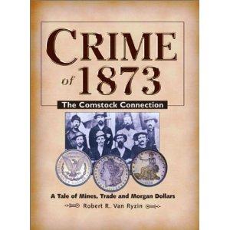
-------1870 – Railroad Monopoly power
-------1870 – Technology Avalanche
------- 1870 – Agriculture
-------1870 – Land Ownership
-------1870(s) Railroad construction

-------1870 - Manufacturing
-------1870 – Commodity Output
-------1870 – Railraod Track Progress
-------1870 – Commercial Bank Stats
-------1870 – Women in the Workplace
-------1870 – State Banking
-------1870 – Energy Advances
-------1870 – Migration

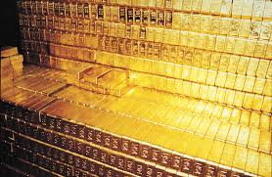
-------1870 – Railroad Regulations
-------1871 – Land-grant
-------1871-1874 Railroad Laws
-------1871 – Land Grants
-------
1873 – Congressional committees
-------1873 – Railroad
-------1873 – Currency Simplification
-------1873 – Crime of ’73
-------1873 – Railroad industry
-------1873 – Railroad construction progress
-------1874 – Democratic Congress Returns Gold Payment
-------1875 - Railroad Federation
-------1875 – Technology Advances
-------1875 – Maintenance of Railroad -
-------1875 – Business
-------1875 – Railroad Track Progress
-------1876 – Business holdings
-------1876 – Business
-------1877 – Federal Debt
-------1877 – Supreme Court Case
-------1877 – Railroad Progress
-------1878 – Silver Value
-------1878 – Purchasing Silver Purchase Law
-------1878 – Silver Acts
-------1878 – Bland-Allison Act
-------1879 – Associations
-------1879 – Horizontal Mergers
-------1879 – Investment Banking Pioneers
-------1879 – Minimum Gold Reserve
-------1879 – 1900 – America’s Gold Standard
-------1879 – Resumption of gold payment
-------1880 – Commodity Output
-------1880(s) – Railroad construction
-------1880 – Commercial Bank Stats
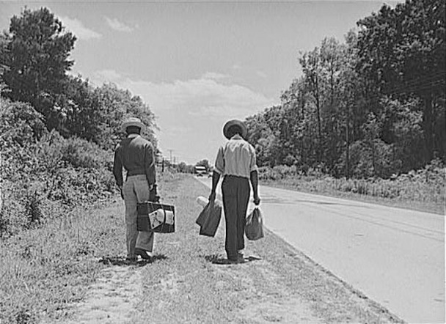
-------1880 – Agriculture
-------1880 – Business
-------1880 – Railroad Track Progress
-------1880 – Business
-------1882 – Railroad Construction Progress
-------1882 – Railroad Progress .
-------1885 – Railroad Track Progress
-------1886 – Haymarket Affair
-------1886 – State Limitations
-------1887 – Act to Regulate Commerce
-------1887 – Interstate Commerce Commission
-------1889 – Security Holdings
-------1890 - State Banks
-------
1890 – Gold Reserve Decline
-------1890 - State Banks
-------1890 – Sherman Silver Purchase Law
-------1890 – Treasury Silver
-------1890 – Commercial Bank Stats
-------
1890 – Technology Advances
-------1890 – Energy Sources .
-------1890 – U,S Power
-------1890 – Energy Sources
-------1890 – Sherman Antitrust Act
-------1890 – Railroad Track Progress
-------1891 – Types of Gold Drain
-------1892 – Letter for Commission
-------1893 – Railroad Construction
-------1893 – Sherman Silver Purchase Law is repealed
-------1893 – Serious Gold Drain
-------1893 – Federal Debt
-------1893 – Panic of 1893
-------1893 – Railroad Progress
-------1894 – Coxey’s Army
-------1894 – Labor Day
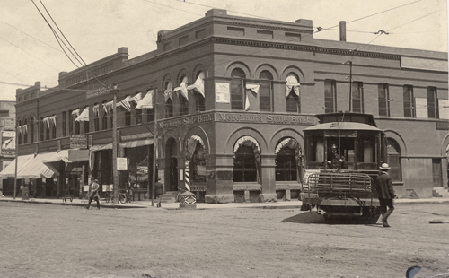
-------1895 – United States v E.C. Knight Company
-------1895 – Technology Advances
-------1895 – Railroad Track Progress
-------1896 – Gold Standard
-------1896 – Increasing Commodity Exports
-------1896 – Heyday of the Gold Standard
-------1896 – Election of 1896
-------1898 – Vertical Mergers
-------1898 – United States v. Addyston Pipe and Steel Company
-------1899 – Workforce
-------1900 – United States Steel Corporation
-------1900 – Gold Standard Act
-------1900 – Commercial Bank Stats
-------1900 – Railroad Track Progress
-------1900 – Birth Rates
-------1902 – Open Shop
-------1903 – The Elkins Act
-------1905 – Railraod Track Progress
-------1906 – Hepburn Act
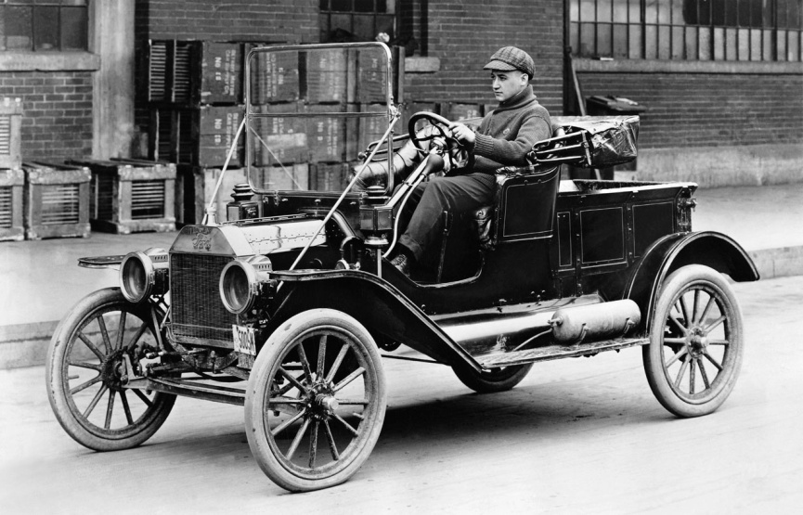
-------1907 - Panic of 1907
-------1908 – Aldrich-Vreeland Act
-------1910 – Commercial Bank Stats
-------1910 - Migration
-------1910 – Railroad Track Progress
-------1910 – Wages
-------1910 – Printing and Publishing
-------1910 – U.S Factories
-------1910 – Manufacturing Output
-------1910 – Workforce
-------
1910 – Technology Advances
-------1910 – Industries
-------1911 – Supreme Court Monopoly Decision
-------1912 – Coppage v. Kansas
-------1912 – Pujo Committee
-------1912 – National Monetary Commission
-------1913 – Federal Reserve System
-------1913 – Industries
-------1914 – Federal Trade Commission
-------1914 – Clayton Act
-------1914 – Commercial Bank Stats
-------1914 – Industries
-------1914 – Automobile Advances
-------1914 – State Banks Overtake National Banks
-------1914 – Railroad Securities
-------1917 – Nationalization of Railroad
-------1917 – Nationalizing Railroad
-------1917 – Federal Reserve Member Bank Deposits
-------1919 – Machinery Advances
-------1919 – Sewing Advances
-------
1919 – Energy Sources
-------1920 – Immigrant Workforce
-------1920 – Child Labor Laws
-------1920 – Workforce
-------1940 – Labor

2000

